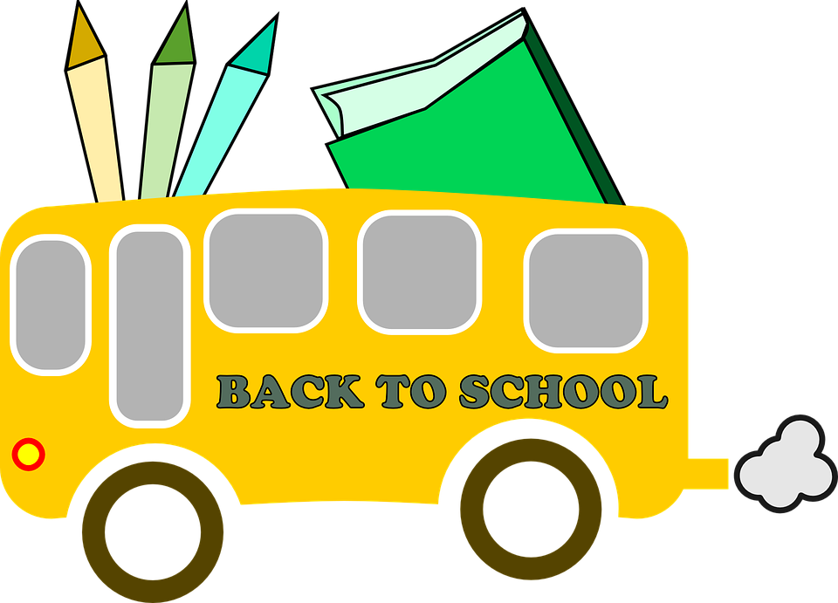

Welcome to Kindergarten!

Another exciting year is about to begin and I am eager and ready for a special year of learning in kindergarten. I hope you all had a relaxing, fun filled summer vacation and are ready to start a new adventure in kindergarten. I am so happy that your child will be in my classroom and attending Columbia Elementary School.
To begin, I would like to share with you my educational background and some personal information. I graduated from Eastern Michigan University with a Bachelor of Science in Elementary Education that includes a triple minor, (Early Childhood Education, Science and Social Science). I have a Master's Degree in Curriculum and Instruction, also from Eastern Michigan University. In addition, I have completed several classes in the instruction of reading and writing for elementary children, classes in technology and Common Core.
I am married and live with my husband in the Brooklyn area. Our children are mostly grown and we have 6 wonderful grandchildren.
I believe that a good parent-teacher relationship is necessary for maximum school success. I encourage you to contact me if you have any questions or concerns throughout the school year. You can send a note, call me at school (592-6632), at my home (592-4030), or e-mail me at leissa.bernstein@myeagles.org. I know that together we can make this a positive adventure for your child. We at Columbia Elementary are here to make this transition into kindergarten a great experience.

The Back to School Bash is August 21st, 5:30-7:00 p.m. I hope you and your child will be able to attend. This is a wonderful opportunity for your child to see their classroom, explore the school and for us to meet. It will also help your child feel more comfortable on the first day of school.

Our first day of school is, Wednesday, August 23rd. It is a half day, school starts at 7:55 A.M. and dismissal is 11:20.

There are some housekeeping tasks for you to complete at home in order for your child to have a successful and stress free first week of school.
☺ Check with Bill Bradley (transportation director) to make sure you know what bus route number your child will ride. The number to the bus garage is 592-6449. Be persistent he is in and out all day.
☺Fill out the enclosed Transportation Sheet and be sure to send with your child on the first day of school!
☺ If at all possible, please email me your child’s name and how he/she will be getting home the first day of school~Pick-up, Latchkey, or Bus (include bus route number). If you choose to email, please do so before Monday, August 21st.

Visit our classroom web-site at www.mrsbernsteinskindergarten.weebly.com for updates, copies of notes and C.E.S. information. We will also have a private Facebook page so you can see pictures of what your child is working on in the classroom and other important information will be posted here. You will find the page if you search Facebook for Mrs. Bernstein’s Kindergarten.

I am looking forward to a great year of learning and growing!
Leissa Bernstein

School Supplies for Mrs. Bernstein’s Class

~A backpack that is large enough to hold library books and snow gear during the winter months – please label with your child’s name

In a plastic or paper bag labeled with your child’s name please put the following. These items will be shared with the class and individual items do not need to be labeled with your child’s name unless noted otherwise.
- 4 (or more) larger sized glue sticks (1.27 oz. Approx)
- 2 packs of crayons – (24 count please)
- 3 or more dry erase markers – any color (please try to stay away from Crayola brand as they don’t seem to wipe off well)
- 1 set of washable markers~ broad tip (boys) fine point (girls)
- 1 box of tissue for the classroom
- 1 large cereal box (please label inside with your child’s name)
- One pair of HEADPHONES (no earbuds please, they don’t fit right in little ears) in a ziploc bag labeled with your child’s name. We use these in the classroom and at computer time.
- A complete change of clothes including socks, underwear, pants, and shirt in a ziploc bag labeled with your child’s name,(we tend to get messy and sometimes have other accidents) These items will be returned if unused at the end of the school year.

Optional Items Mrs. Bernstein Can Always use:
- Small and large paper plates
- Clorox Wipes-any brand works fine
- Gallon and quart zip lock baggies
- Brown paper lunch bags and white paper lunch bags
- ANY Crafting & Art Supplies – pipe cleaners, wiggly eyes, glitter, pom-poms, foam pieces, foam letters, pictures frames to paint/decorate, etc.

Other Important First Day Information

Transportation Form
Please, please, please fill out the enclosed transportation form completely and bring it with you to the open house. It is imperative that I have this so I can get your little angel to the right place at the end of the day!! If at all possible, email me the first day transportation info at leissa.bernstein@myeagles.org

Drop off
Families who drop of their children can drop them off using the circle drive located between Columbia Upper Elementary School and Columbia Elementary.
Simply drive around the circle drive and proceed to the entrance of CES to drop off your child. The right lane will be a drop off lane, while the left line is a passing lane. Please do not stop in the left lane.

Pick Up
Every child will receive an orange sheet with your last name on it. If you will be picking your child up at the end of the day, please place your name paper in the front window of your car. You can drive through the circle drive to CES main entrance, where your child will be walked to your car. Please do not walk up to the porch, a staff member will deliver your child to your car.

Snack
Please send a healthy snack (and juice box or small water if you wish) each day in your child’s backpack. PLEASE put your child’s snack in the OUTSIDE ZIPPER POCKET of their backpack - separate from their lunch so that your child knows where their snack is. Otherwise, they may accidentally eat their snack at lunchtime and then have no snack! I will provide a snack the 1st day.

Blue CES Folder
I will be giving your child a BLUE FOLDER. Please check your child’s blue folder each day and send it to school EVERY day in their backpack. This is how I communicate with you on a daily basis. Many important papers will come home the first week and some will need to be returned. If you have anything important for me (lunch money, notes about pick up, anything!) you should put it in this folder and I will be sure to get it!

Lunch Money
If your child plans to buy lunch, please send the money in a ziplock baggie with your child’s full name & my name written on the envelope/baggie. You can pay daily/weekly/monthly or yearly! The first day of school is only a ½ day – so we don’t have to worry too much about this until DAY #2!!!

Pete The Cat Picture
Color the picture and bring it with you to the 1st day of school and I will give you a surprise.

